|  |  |  |
| --- | --- | --- |
| **CSC 310 Human Computer Interaction**  **Heuristic Evaluation Report Template**  **Dated**  **11/22/2020**   |  | | --- | | **Prepared By:**  **GROUP NAME: Group 1**  **CONTRIBUTOR: Cason Konzer** |  |  | | --- | | **Evaluation Of:**  **Name of system being evaluated: CODE : : BLOCKS v 2003**  **Group that created the system being evaluated: Group 5** | |

## 

|  |  |
| --- | --- |
| Feedback & Critical Incidence | << Record your observations in the table on the following page, based on your observations and notes taken during the evaluation.  Description of columns in the table are as follows:  *Prototype Screen/Page:*  Which screen of the user interface was being tested at the point of feedback/critical incidence/problem.  *Name of Heuristic:*  Which of the 9 heuristics is being referenced. Enter the full name of the heuristic. Refer to the heuristic evaluation lecture slides for the 9 design principles.  *Reason for negative feedback / breakdown:*  Explain the reasons why the interface violates this heuristic. Be sure to be clear about *where* in the screen you are referencing.  *Scope:*  Describe the scope of the feedback or the problem; include whether the scope of the issue is throughout the product or within a specific screen or screens. If the problems are specific to a page, include the appropriate page numbers.  *Severity (H/M/L) :*  Your assessment as to whether the implication of the feedback is *low*, *medium*, or *high* severity, and a justification for why you are giving it that rating.    *Way(s) to rectify and Tradeoffs (i.e., why the fix might not work):*  Suggestion for the modifications that might be made to the user interface to address the issue or issues in this row. You MUST include trade-offs to be credible. If you can’t think of some bad trade-off, say so.  *Action taken and Justification:*  DO NOT FILL IN THIS COLUMN. This will be filled in by the person who created the system being evaluated, to say what he did with respect to the recommendations you make. |

| **#** | **Prototype Screen** | **Name of Heuristic** | **Reason for negative feedback / breakdown** | **Scope** | **Severity**  (High/ Medium/ Low) and **Justification** for giving it that rating | **Way(s) to rectify and any Tradeoffs** (i.e., why the fix might not work) | **Action taken and Justification (*to by filled in later by the person who created the system being evaluated*)** |
| --- | --- | --- | --- | --- | --- | --- | --- |
| 1 | See Picture 1 | Be Consistent,  Provide clearly marked exits | This is a “dead” screen. The Read Me provides instructions that are not consistent with the model. There is no way for the user to leave this screen while they are directed here by the instructions. | Error occurs in this screen as well as some others | High. At this point the user has made 3 total clicks and is stuck on a screen. The cancel button does not function nor does any button on the screen. | Implement the cancel button to return to home screen. Implement the Console Application button so the user can complete the given directions. |  |
| 2 | See Picture 2 | Be Consistent,  Provide clearly marked exits | Read me directs user to press an edit mode button that is not available. Prototype has an edit profile button that does not work. Exit button is very hard to see. | Various screens do not have clearly marked exits, whole project is quite inconsistent with project directions and read me. | High. User has no way of advancing through the given script at this point. | Implement the edit button, either change the read me or project, mode/profile, so they are consistent. Make the exit button more pronounced. |  |
| 3 | See Picture 3 | Simple and Natural Dialog,  Speak the User’s Language, Be Consistent | Am unsure what the given script actually is, read me assume user has a background with technical language, wordage does not logically flow with the English language. (Do not think people would talk like this). | Project Wide. The read me is crucial for providing instructions for completion of tasks. | High. Read me is not consistent with the prototype. Read me is hard to follow. Some wordage is not in layman terms and users may get stuck. | Match the read me with the project so that they are consistent. Provide clear script labeling. Speak in layman terms so the prototype can be tested with new users. |  |
| 4 | See Picture 4 | Provide clearly marked exits | No exit available | Present within multiple project screens | Low. User can continue to navigate without the exit but this is a necessary feature. | Add in an exit |  |
| 5 | See Picture 5 | Be Consistent,  Provide clearly marked exits | This suffers similar errors as the only functioning click through is clicking Main.cpp which simply returns the user to the previous screen. The Read Me says to click Toggle Breakpoint, which is not consistent with what the prototype offers. | Inconsistency and lack of implementation is project wide. | High. Again, at this point the user cannot complete directions as the read me indicates. Additionally, there is no clear exit and the user will easily be stuck here. | Implementation of the toggle breakpoint button as the read me states. Provide an exit button. |  |
| 6 | See Picture 6 | Provide Help | While the help button opens up various help options there is no help provided | Project wide | Low. Help can be found in the read me. | Implement help dialog. |  |
| 7 | Project Wide | Provide Feedback, Be Consistent | No feedback to the users for any unimplemented buttons, buttons are only available on certain screens | Project Wide | Medium. Unimplemented buttons do not provide any feedback for the user and while buttons are available on one screen they may not be on the next. | Provide popups/ screens with a message of the “coming soon…” type. Be consistent and implement buttons on all screens. |  |

Picture 1:

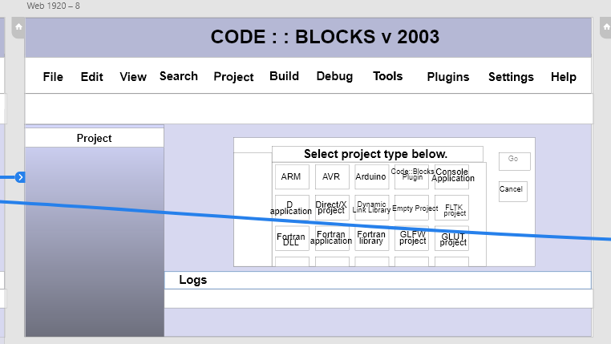

Picture 2:

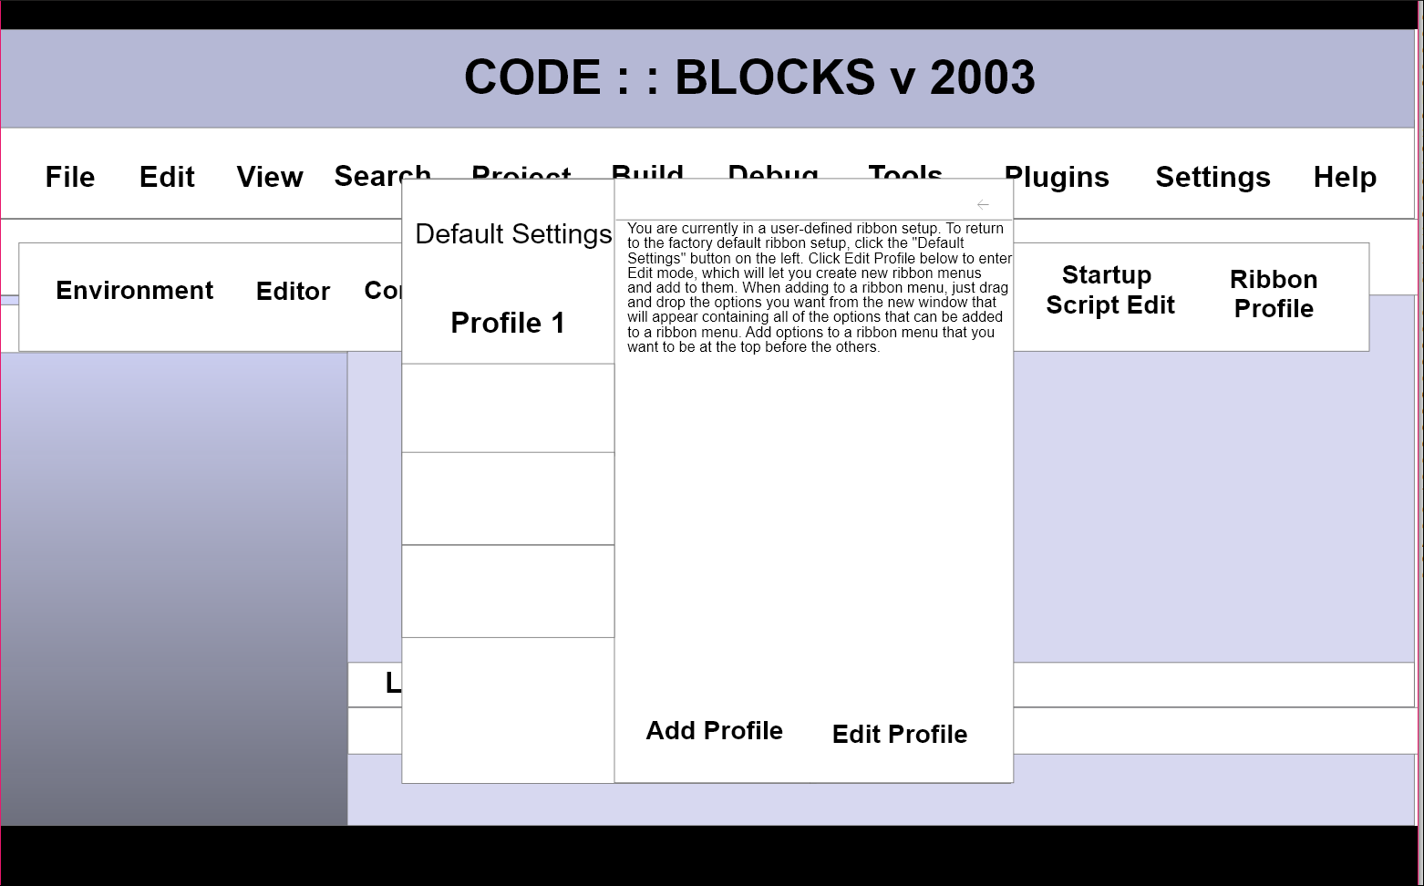

Picture 3:

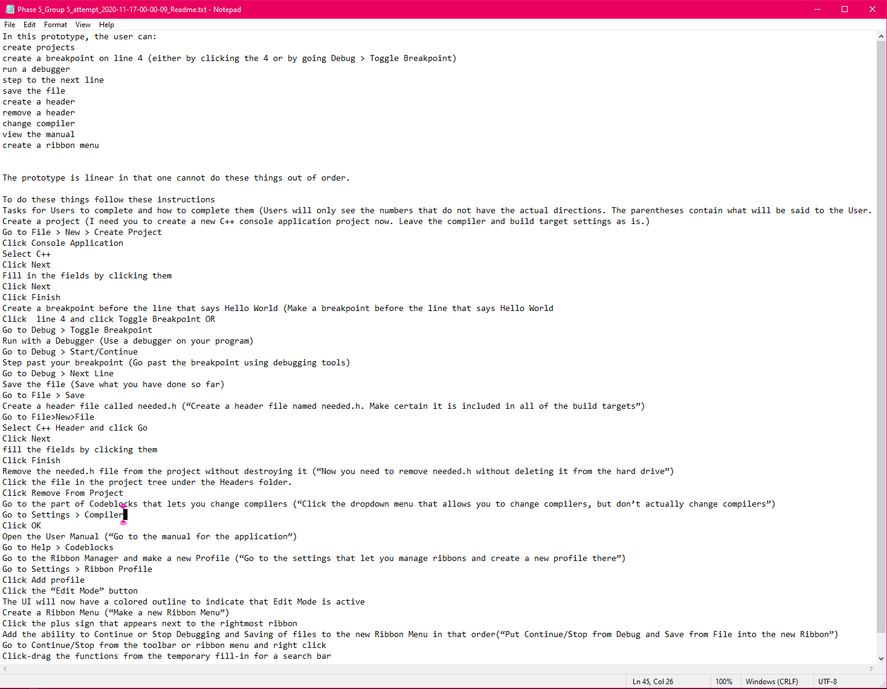

Picture 4:

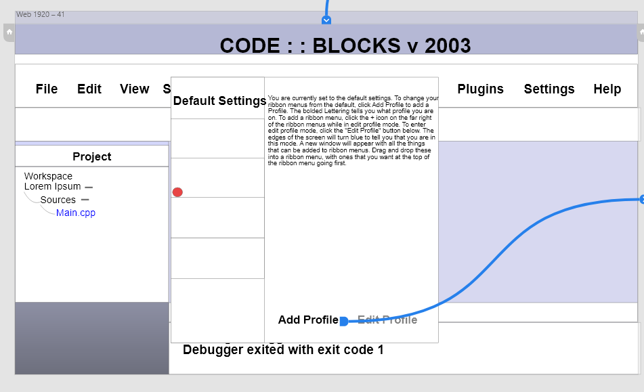

Picture 5:

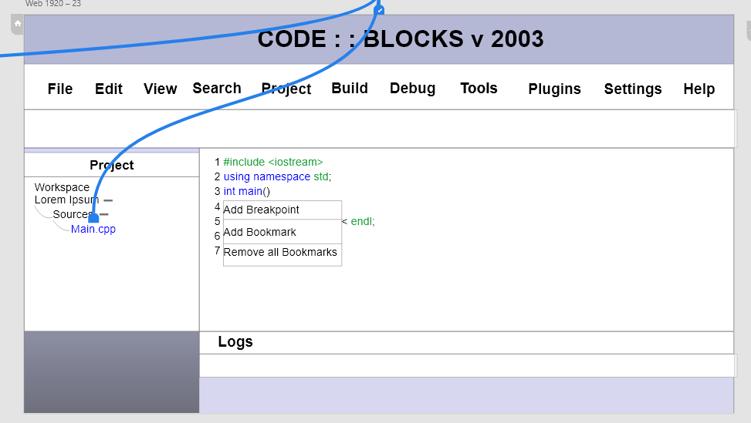

Picture 6:

